Expressive arts tasks

Below are some expressive arts tasks for you to try at home.

Make shadow puppets! You can use paper or card to cut out shapes. You can stick the shapes onto sticks then shine a torch or a light against a background and act out some scenes. If you don’t have the resources, you could also use your hands.
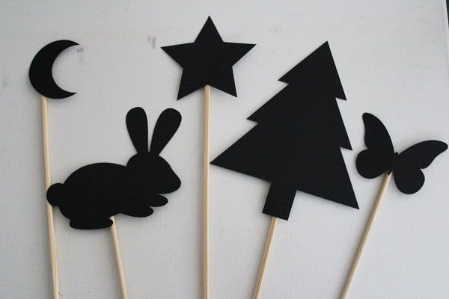
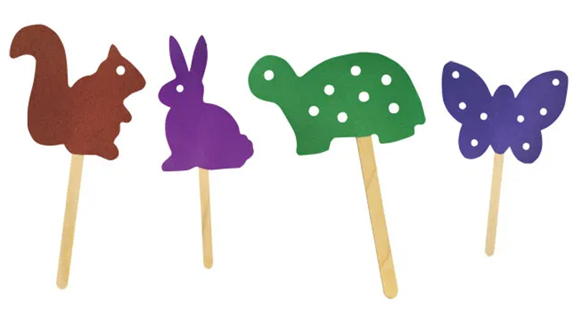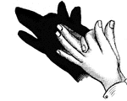

Go through your recycling and see what container you can find to make a shaker. You could use an empty kitchen roll or even an empty carton of milk. Fill it halfway with empty dry ingredients from your cupboards, for example rice or lentils. Make sure it is closed properly and tightly before shaking! Feel free to decorate it however you like.

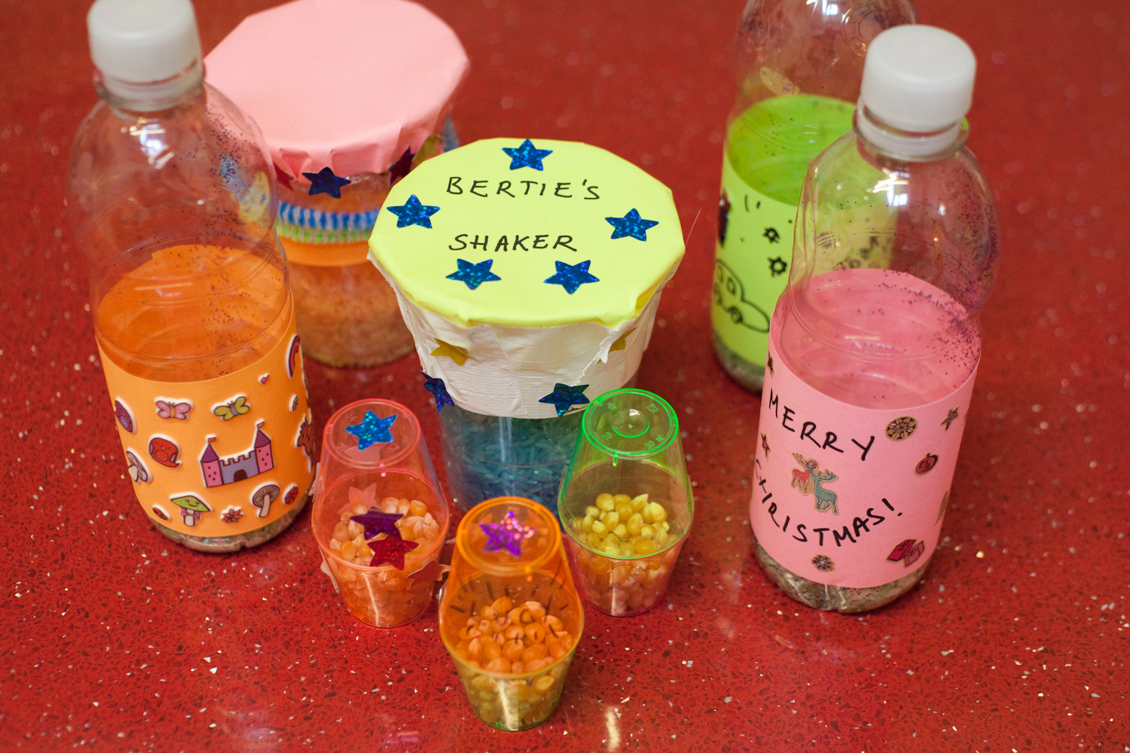

See what you have available from your recycling to make a junk model creation. Try and link it to the theme of ‘above and below’. For example, you could make a spaceship, a boat or anything that interests you!
