Pink | Pink word cards Phase 2 HFWs | - Phase 2 Phonics  - Reading simple CVC words  - Locating title, turning pages appropriately
Red | Orange word cards  Phase 3 HFWs | - Phase 3 Phonics  - Blending simple CVC words
Yellow | Orange word cards  Phase 3 HFWs | - Phases 3/4 Phonics  - Predicting, taking notice of punctuation
Blue | Blue word cards  Phase 4 HFWs | - Phases 4/5 Phonics  - Using punctuation to read with expression, inference
Green | Green word cards  Phase 5 HFWs | - Phase 5 Phonics  - Inference about characters, features of fiction and non-fiction texts
Orange | Black word cards  Year 1 common exception words | - Using syllables to read longer words, talking about characters’ feelings
Turquoise | Black word cards  Year 1 common exception words | - Reading with greater expression, comparing stories, locating answers in the text
Purple | Grey word cards  Year 2 common exception words | - Solving most unfamiliar words, discussing author’s word choices, using index and contents page
Gold | Grey word cards  Year 2 common exception words | - Reading multi-syllable words, discussing how the plot links together, identifying other books by the same author
White | n/a | - Books with chapters and fewer illustrations, understanding a wider range of vocabulary, discussing the feelings created by the story
Lime | n/a | - Books with a range of sentence structures, able to discuss different text types (e.g. poetry and plays).
A Guide to Banded Books

Pink
What to work on:
- Look at the pages in order and show your child that we read from left to right.
- Encourage your child to sound out words he/she cannot read yet.
- Talk about the whole story or what your child found out from the book.
Look out for these pink level books in the library:
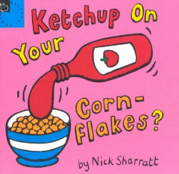
Ketchup on Your Cornflakes by Nick Sharrat
Do You Want to be My Friend by Eric Carle
Yes by Jez Alborough
Banana! by Ed Vere
Colours by Jan Pienkowski
Pirate Picnic by Juliet Bell
My Dinosaur Dad by Ruth Paul
I Like Books by Anthony Brown
At the Water Hole by Jane Clarke
Look Inside by Rod Campbell

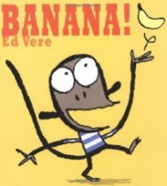

Useful words to learn:
an | it | had | his | put | I
as | of | back | not | a | into
at | off | and | got | the
if | on | get | up | to
in | can | big | mum | no
is | dad | him | but | go

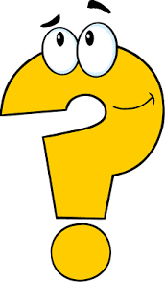
Your child will keep the same reading book for a week. Please ask lots of questions to encourage your child to talk about the book.

Questions to ask:
Before reading  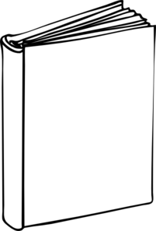 | - Can you point to the title of the book?  - Can you show me the front cover?  - What do you think the book is going to be about?  - Can you find the first page of the story?
During reading  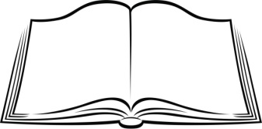 | - What do you think is going to happen next?
After reading  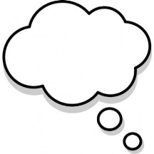 | - What happened in the book?

Red
What to work on:
- Encourage your child to sound out words he/she cannot read yet.
- After reading the book a few times, encourage your child to read more quickly and without sounding out each word.
- Talk about the whole story or what your child found out from the book.
Look out for these red level books in the library:
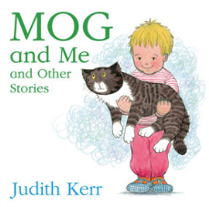
Mog and Me by Judith Kerr
Brown Bear, Brown Bear by Bill Martin
From Head to Toe by Eric Carle
Sometimes… by Emma Dodd
The Hungry Cat by Phyllis King
Quack, Quack by Patricia Casey
I Spy With My Little Eye by Edward Gibbs
To the Beach by Thomas Docherty
The Ball Bounced by Nancy Tafuri
“Pardon?” said the Giraffe by Colin West

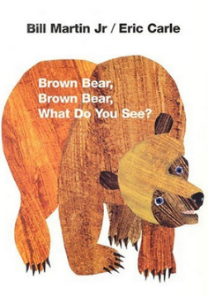

Useful words to learn:
will | see
that | for
this | now
then | down
them | look
with | too

Your child will keep the same reading book for a week. Please ask lots of questions to encourage your child to talk about the book.

Questions to ask:
Before reading | - Can you point to the title of the book?  - Can you read the title?  - What do you think the book is going to be about?  - Can you find the name of the author?  - Do you think this book is going to be fiction (a story) or non-fiction (information)?
During reading  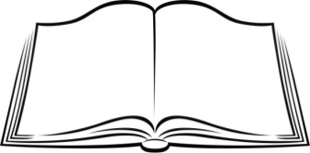 | - Who is the main character?  - Where does this story take place?
After reading | - Can you retell the story?  - What did you like/dislike about this book?

Yellow
What to work on:
- Give your child time to recognise and correct mistakes.
- Ask your child to talk about what is happening in the book and to predict what might happen next.
- Talk about links with other books the child might have read (e.g. similar characters or setting).

Look out for these yellow level books in the library:
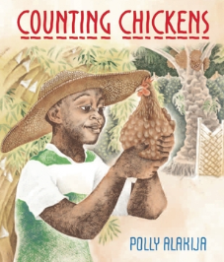
Stomp! By Jeanne Willis
I Want My Dinner! By Tony Ross
Ten Out of Bed by Penny Dale
Counting Chickens by Polly Alakija
Pete the Cat by Eric Litwin
Each Peach Pear Plum by Allan and Janet Ahlberg
Noisy Farm by Rod Campbell
One Mole Digging a Hole by Julia Donaldson
The Great Food Robbery by Jill Atkins
Baby Goz by Steve Weatherill

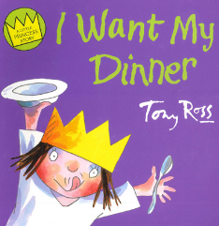

Useful words to learn:
he | you
she | they
we | all
me | are
be | my
was | her

Your child will keep the same reading book for a week. Please ask lots of questions to encourage your child to talk about the book.

Questions to ask:
Before reading | - Can you read the title?  - Can you find the blurb?  - What do you think the book is going to be about?  - Have you read any other books by this author?  - Do you think this book is going to be fiction (a story) or non-fiction (information)?
During reading | - Why has bold writing or capital letters been used here?  - What is happening in the story? Has anything like that ever happened to you?  - Where does the story take place? Have you ever been to a place like that?
After reading | - Can you retell the story using some words from the book?  - What did you like/dislike about this book?

Blue
What to work on:
- Encourage your child to pay attention to punctuation and use punctuation to add expression.
- Talk about the differences between fiction (story books) and non-fiction (information books).
- Ask your child questions about why a character acted in a certain way.
Look out for these blue level books in the library:
When We Went to the Park by Shirley Hughes
Bear Hunt by Anthony Browne
Dear Zoo by Rod Campbell
Wolf Won’t Bite! By Emily Gravett
Ten in the Bed by Penny Dale
Hippo Has a Hat by Julia Donaldson
The Odd Egg by Emily Gravett
Alfie the Sea Dog by Mick Gower
Rosie’s Walk by Pat Hutchins
One Day in the Jungle by Colin West
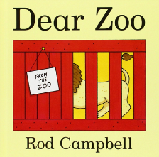

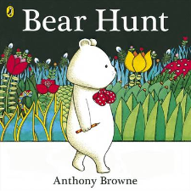

Useful words to learn:
went | help | one | come
from | said | have | there
children | were | do | what
it’s | out | when | so
just | like | some

Your child will keep the same reading book for a week. Please ask lots of questions to encourage your child to talk about the book.

Questions to ask:
Before reading | - Can you read the title?  - Can you find and read the blurb?  - What do you think the book is going to be about? Why?  - Have you read any other books by this author?  - Do you think this book is going to be fiction (a story) or non-fiction (information)?  - Why do we read fiction/non-fiction books?
During reading | - Why has bold writing or capital letters been used here?  - What is happening in the story? Has anything like that ever happened to you?  - Where does the story take place? Have you ever been to a place like that?  - Why does the character….?
After reading | - Can you retell the story using some words from the book?  - What did you like/dislike about this book?  - Can you think of a different ending to the story?

Green
What to work on:
- Encourage your child to sound out quickly and silently.
- Show your child how to find out information when reading non-fiction books.
- Talk about why certain events happened in the story or why characters acted as they did.

Look out for these green level books in the library:
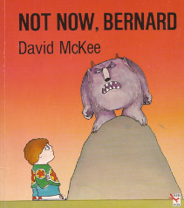
Titch by Pat Hutchins
A Dark, Dark Tale by Ruth Brown
Planets by Charlotte Guillane
Wow! Said the Owl by Tim Hopgood
Not Now, Bernard! By David McKee
Solomon Crocodile by Catherine Rayner
I Want My Hat Back by Jon Klassen
The Scary Monster by Axel Scheffler
The Foot Book by Dr Seuss
Chicken, Chips and Peas by Allan Ahlberg

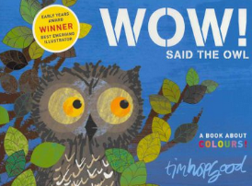

Useful words to learn:
Mr | old | your | their
Mrs | about | very | day
called | made | by | saw
could | asked | time | here
looked | I’m | came | oh
don’t | make | people

Your child will keep the same reading book for a week. Please ask lots of questions to encourage your child to talk about the book.

Questions to ask:
Before reading | - Can you read the title?  - Can you find and read the blurb?  - Can you find the name of the illustrator?  - What do you think the book is going to be about? Why?  - Why have you chosen to read this book?  - Have you read any other books by this author?  - Why do we read fiction/non-fiction books?  - Do you think this book is going to be fiction (a story) or non-fiction (information)?  - If reading non-fiction: Can you find the glossary? Can you find the contents page?
During reading | - Why has bold writing or capital letters been used here?  - What is happening in the story? Has anything like that ever happened to you?  - Where does the story take place? Have you ever been to a place like that?  - Why does the character….?  - If reading non-fiction: What have you learnt from this page?
After reading | - Can you retell the story using some words from the book?  - What did you like/dislike about this book?  - What was your favourite part of the book?  - Can you think of a different ending to the story?

Orange
What to work on:
- Encourage your child to use expression when a character is speaking.
- Ask questions about how the characters are feeling.
- Talk about what might happen next based on the story so far.

Look out for these orange level books in the library:
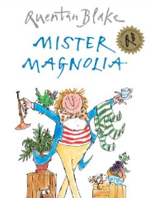
Mister Magnolia by Quentin Blake
The Very Hungry Caterpillar by Eric Carle
We’re Going on a Bear Hunt by Michael Rosen
Willy and Hugh by Anthony Browne
How to Catch a Star by Oliver Jeffers
I’m Not Scared! By Jonathan Allen
Peace At Last by Jill Murphy
Boy by James Mayhew
Oscar Got the Blame by Tony Ross
Never Use a Knife and Fork by Neil Goddard

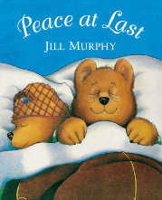

Useful words to learn:
do | your | friend | full
today | love | push | house
says | once | pull | new

Your child will keep the same reading book for a week. Please ask lots of questions to encourage your child to talk about the book.

Questions to ask:
Before reading | - What do you think the book is going to be about? Why?  - Why have you chosen to read this book?  - Have you read any other books by this author?  - Do you think this book is going to be fiction (a story) or non-fiction (information)?  - Why do we read fiction/non-fiction books?  - If reading non-fiction: Can you find the glossary? Can you find the contents page? Can you find the index?
During reading | - Why has bold writing or capital letters been used here?  - What is happening in the story? Has anything like that ever happened to you?  - Where does the story take place? Have you ever been to a place like that?  - Why does the character….?  - What do you think is going to happen to this character next?  - Does this remind you of any other books you have read?  - Can you show me where to find the answer in the text? Where does it tell you that…?  - If reading non-fiction: What have you learnt from this page?
After reading | - Can you retell the story using some words from the book?  - What did you like/dislike about this book?  - What was your favourite part of the book?  - Can you think of a different ending to the story?
Turquoise
What to work on:
- Discuss the behaviour, appearance and personality of characters in a story.
- Encourage your child to point to sentences in the text to show where he/she found an answer.
- Talk about the meaning of vocabulary and why certain words have been used.

Look out for these turquoise level books in the library:
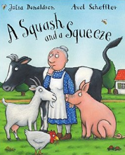
Gorilla by Anthony Browne
A Squash and a Squeeze by Julia Donaldson
The Pig in the Pond by Martin Waddell
We’re Going on a Lion Hunt by David Axtell
Oi! Get Off Our Train by John Burningham
Funnybones by Janet and Allan Ahlberg
Meg and Mog by Jan Pienkowski
Big Red Balloon by Anne Fine
Frog and Toad are Friends by Arnold Lobel
The Very Busy Spider by Eric Carle

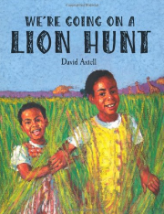

Useful words to learn:
can’t | something | I’ve | please
didn’t | couldn’t | I’ll
school | know | who
Your child will keep the same reading book for a week. Please ask lots of questions to encourage your child to talk about the book.

Questions to ask:
Before reading | - What do you think the book is going to be about? Why?  - Why do we read fiction/non-fiction books?  - If reading non-fiction: Can you find the glossary? Can you find the contents page? Can you find the index?
During reading | - Why has bold writing or capital letters been used here?  - What is happening in the story? Has anything like that ever happened to you?  - What do you think is going to happen next? Why?  - Does this remind you of any other books you have read?  - Can you show me where to find the answer in the text? Where does it tell you that…?  - If reading non-fiction: What have you learnt from this page?
After reading | - Can you retell the story using some words from the book?  - Can you describe the main character?  - Can you go back and find the page where…?  - What was your favourite part of the book? Why did you like that part?  - Can you think of a different ending to the story?  - What is the main theme of the story? (e.g. Is it a book about friendship? Is it a book about bravery?)  - Who would you recommend this book to? Why?

Purple
What to work on:
- When reading non-fiction, encourage your child to use the contents and index to choose a page of interest.
- Talk about interesting parts of the book.
- Encourage your child to find out the meanings of new words.

Look out for these purple level books in the library:
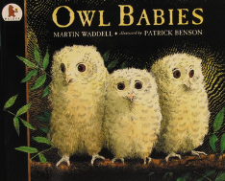
Owl Babies by Martin Waddell
Grace and Family by Mary Hoffman
Mirror Mirror by Karen Wallace
Mr Archimede’s Bath by Pamela Allen
Mr Gumpy’s Motor Car by John Burningham
The Tale of Peter Rabbit by Beatrix Potter
Hairy Maclary from Donaldson’s Dairy by Lynley Dodd
A House in the Woods by Inga Moore
Elmer by David McKee
Where the Wild Things Are by Maurice Sendak

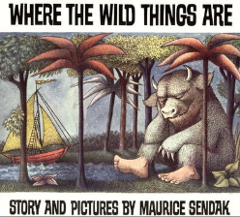

Useful words to learn:
door | kind | child | gold
floor | find | wild | old
poor | mind | most | hold
because | behind | only | told

Your child will keep the same reading book for a week. Please ask lots of questions to encourage your child to talk about the book.

Questions to ask:
Before reading | - What do you think the book is going to be about? Why?  - Who is the author? Who is the illustrator?  - If reading non-fiction: Can you find the glossary? Can you find the contents page? Can you find the index? Can you use these pages to find an interesting page to read?
During reading | - Why has bold writing or capital letters been used here?  - What is happening in the story? Has anything like that ever happened to you?  - What do you think is going to happen next? Why?  - Does this remind you of any other books you have read?  - Can you show me where to find the answer in the text? Where does it tell you that…?  - What does this word mean? How could you find out?
After reading | - How are the characters similar to those in other books?  - Can you describe the main character?  - Can you go back and find the page where…?  - What was your favourite part of the book? Why did you like that part?  - Can you think of a different ending to the story?  - What is the main theme of the story? (e.g. Is it a book about friendship? Is it a book about bravery?)  - Who would you recommend this book to? Why?
Gold
What to work on:
- Talk about and compare books by the same author.
- Discuss favourite words or phrases from a book.
- Spot rhyming patterns and repeated words.

Look out for these gold level books in the library:
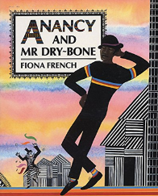
Princess Smartypants by Babette Cole
Prince Cinders by Babette Cole
The Smartest Giant in Town by Julia Donaldson
Into the Forest by Anthony Browne
Willy the Wizard by Anthony Browne
A Piece of Cake by Jill Murphy
Dogger by Shirley Hughes
Anancy and Mr Dry-Bone by Fiona French
The Giant Jam Sandwich by Lord John Vernon
The Queen’s Knickers by Nicholas Allen

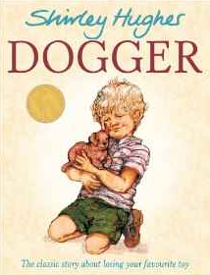

Useful words to learn:
every | everybody | even | great
pretty | beautiful | after | fast
last | past | father | grass
money | pass | plant | hour
move | half | should | would
whole | any | clothes | parents

Your child will keep the same reading book for a week. Please ask lots of questions to encourage your child to talk about the book.

Questions to ask:
Before reading | - What do you think the book is going to be about? Why?  - Who is the author? Who is the illustrator?  - If reading non-fiction: Can you find the contents page? Can you find the index? Can you use these pages to find an interesting page to read?
During reading | - Why has bold writing or capital letters been used here?  - What is happening in the story? Has anything like that ever happened to you?  - What do you think is going to happen next? Why?  - Does this remind you of any other books you have read?  - Can you show me where to find the answer in the text? Where does it tell you that…?  - What does this word mean? How could you find out?  - Which are your favourite words on this page?  - If reading non-fiction: What do these diagrams show? What do these captions tell you?
After reading | - How are the characters similar to those in other books?  - Can you go back and find the page where…?  - What is the main theme of the story? (e.g. Is it a book about friendship? Is it a book about bravery?)  - Who would you recommend this book to? Why?  - What kind of books do you like?
White
What to work on:
- Ask your child to talk about words used to describe characters or places in the book.
- Discuss what type of books your child enjoys and why.
- Make sure that your child is able to read these sight words:

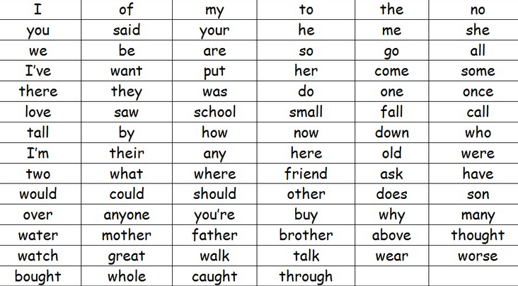

Look out for these white level books in the library:
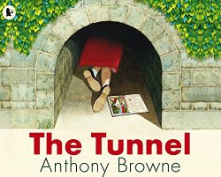
Yeti Spaghetti by Samantha Hay
Hal the Pirate by June Crebbin
The Tunnel by Anthony Browne
Six Dinner Sid by Inga Moore
The Pea and the Princess by Mini Grey
The Hut that Grew by Annie Dalton
The Emperor of Absurdia by Chris Riddell
The Quick Brown Fox Cub by Julia Donaldson
Sixes and Sevens by John Yeoman and Quentin Blake

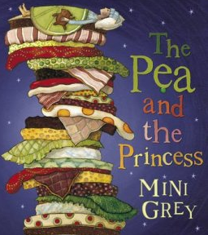

Your child will keep the same reading book for a week. Please ask lots of questions to encourage your child to talk about the book.

Questions to ask:
Before reading | - What do you think the book is going to be about? Why?  - Who is the author? Who is the illustrator?  - If reading non-fiction: What would you like to learn from this book? Can you use these pages to find an interesting page to read?
During reading | - Why has bold writing or capital letters been used here?  - What is happening in the story? Has anything like that ever happened to you?  - What do you think is going to happen next? Why?  - Does this remind you of any other books you have read?  - Can you show me where to find the answer in the text? Where does it tell you that…?  - What does this word mean? How could you find out?  - Which are your favourite words on this page? Why?  - If reading non-fiction: What do these diagrams show? What do these captions tell you?
After reading | - How are the characters similar to those in other books?  - Can you go back and find the page where…?  - What is the main theme of the story? (e.g. Is it a book about friendship? Is it a book about bravery?)  - Who would you recommend this book to? Why?  - What kind of books do you like?
Lime
What to work on:
- Encourage your child to talk about how the book made him/her feel.
- Talk about the themes in a book and similarities between books (e.g. How do fairy tales usually begin?)
- Encourage your child to scan a page to find information.

Look out for these lime level books in the library:
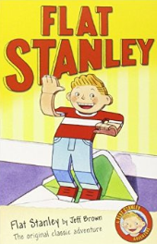
Welcome Home, Anna Hibiscus! By Atinuke
Twelve Dancing Princesses by Saviour Pirotta
The Monster Storyteller by Jaqueline Wilson
Goldilocks and the Pea by Katie Dale
Flat Stanley by Jeff Brown
Pup on the Pitch by Sophie Smiley
Don’t Forget Tiggs! By Michael Rosen
The Knight of Swords and Spooks by Terry Deary
Mr Giant and the Beastly Baron by Tony Bradman
The Julian Stories by Ann Cameron

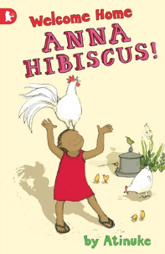

Your child will keep the same reading book for a week. Please ask lots of questions to encourage your child to talk about the book.

Questions to ask:
Before reading | - What do you think the book is going to be about? Why?  - Who is the author? Who is the illustrator?  - If reading non-fiction: What would you like to learn from this book? Can you use these pages to find an interesting page to read?
During reading | - Why has bold writing or capital letters been used here?  - What do you think is going to happen next? Why?  - Does this remind you of any other books you have read?  - Can you show me where to find the answer in the text? Where does it tell you that…?  - What does this word mean? How could you find out?  - Which are your favourite words on this page? Why?  - If reading non-fiction: What do these diagrams show? What do these captions tell you?
After reading | - How are the characters similar to those in other books?  - Can you go back and find the page where…?  - What is the main theme of the story? (e.g. Is it a book about friendship? Is it a book about bravery?)  - Who would you recommend this book to? Why?  - What kind of books do you like?  - How did this book make you feel?

