
How to log on to Mathletics
- Go to https://login.mathletics.com/
- Input username and password details – your class teacher can provide you with these if you do not already have them
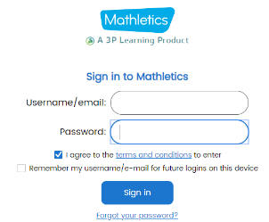

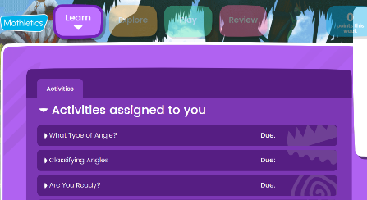
- Once signed in you will see the activities assigned to you by your class teacher

- Click onto one of the activities and the questions linked to that activity will appear
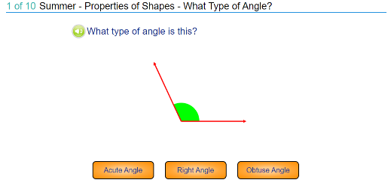

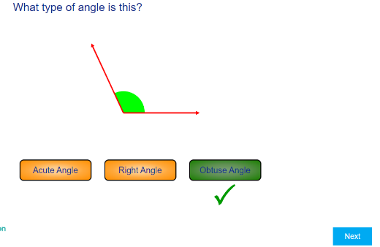
- Choose what you think is the correct answer then hit ‘submit’ and the next questions will appear

- Once you have completed the ten questions for that topic click the ‘x’ at the top right of the screen and you will be taken back to the homepage which shows you the activities you have been assigned
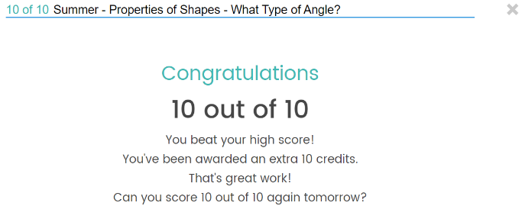

- If you have completed all the assigned activities, you can then choose to practice any of the other activities

