
How to log on to TT Rockstars
- Go to https://ttrockstars.com/
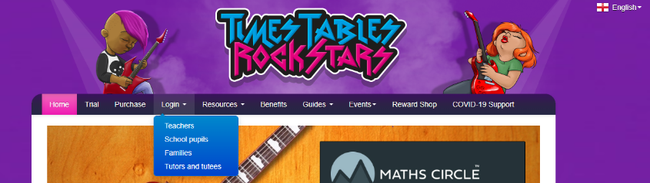
- Click ‘Login’ and then ‘school pupils’

- You are then required to type in the school postcode – SE16 4SU
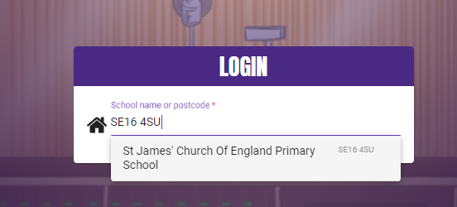

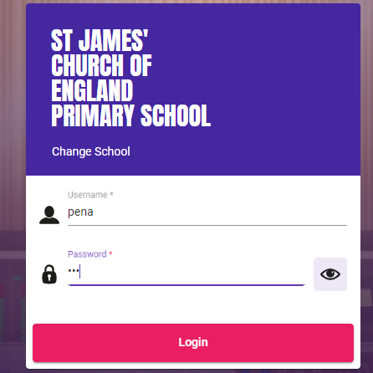
- Enter your username and password, make sure that it says ‘St James’ Church of England Primary School’

- Choose the level you wish to play from ‘Garage’ to ‘Rockslam’
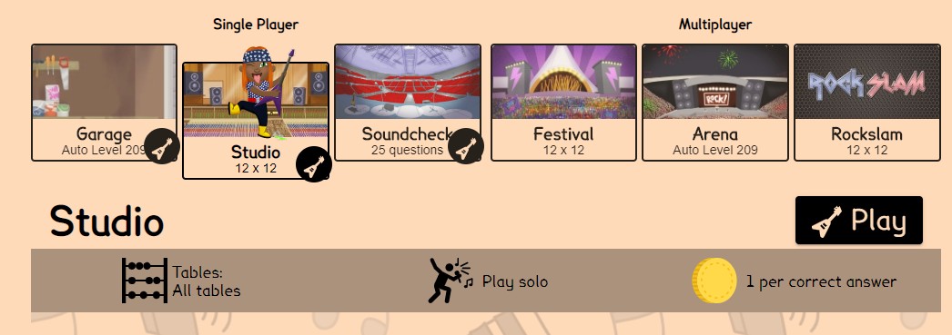

- Once you have chosen a level click ‘play’
- Answer as many questions as you can in the time
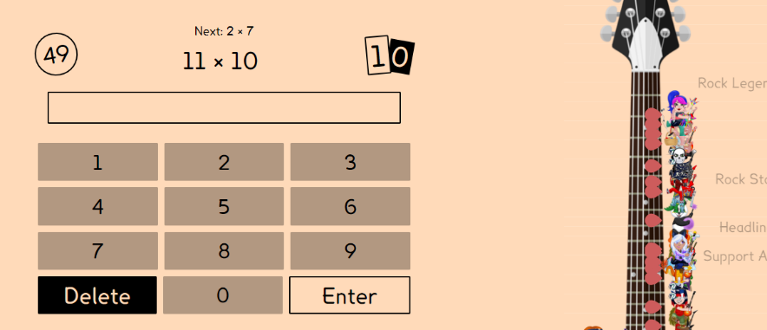

- Take a look at your results, you can then go back to the home page and challenge yourself on another level


