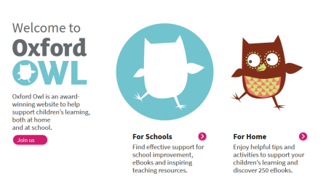
Useful websites for reading:
- Oxford Owl
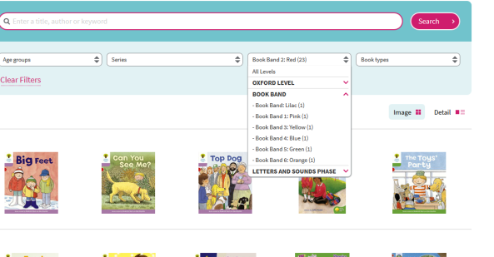
https://www.oxfordowl.co.uk/
This website has eBooks and games for each book band level.

- Help a Hedgehog
http://www.ictgames.com/helpAHedgehog/index.html
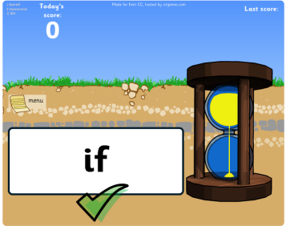
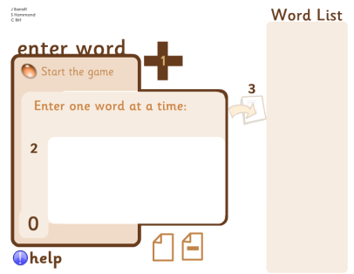
Sit with your child to use this website. Create a list of words for your child to read.

- High Frequency Word Flash Cards
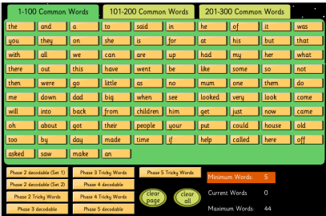
http://www.iboard.co.uk/iwb/Flash-Cards-High-Frequency-Version-213
This game is very similar to Help a Hedgehog. Click on the words to create a list for your child to read.

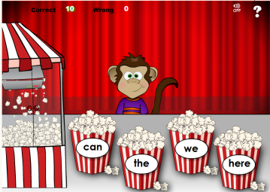
- Popcorn Words
http://www.fun4thebrain.com/English/popcornWords.html
The monkey says a word and your child has to choose the correct box. Your child can play this game alone.
Useful websites for spelling:

- Spelling City
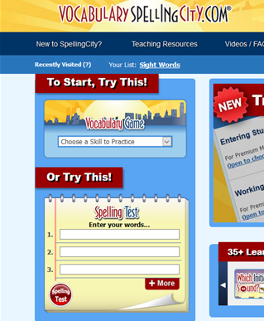
http://www.spellingcity.com/
Create a word list to test your child’s spellings.

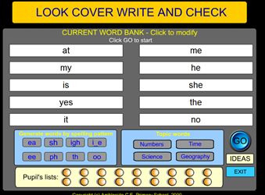
- Look, cover, write, check
http://www.amblesideprimary.com/ambleweb/lookcover/lookcover.html
Create a word list for your child to practise the spellings using the look, cover, write, check method.

