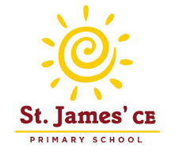
I’m in Year Three, what might I like to read?
Willa and Old Miss Annie – Berlie Doherty
Picasso Perkins – Adele Geras
All Because of Jackson – Dick King-Smith
Mrs Cockle’s Cat – Phillipa Pearce
The Railway Cat – Phyllis Arkle
Charlotte’s Web – E.B White
The Werepuppy – Jacqueline Wilson
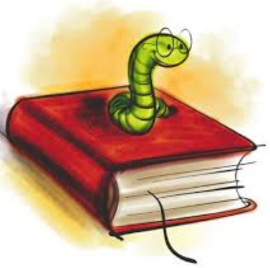
Mr Popper’s Penguins – Richard & Florence Atwater
The Dog Who Changed the World – Robert Leeson
Lazy Daisy – Rob lewis
The Midnight Fox – Betsy Byars
Animals of Farthing Wood Series – Colin Dann
The Peppermint Pig - Nina Bawden
Magic Kitten series - Sue Bentley
Sheltie - Peter Clover
Puppy Patrol - Jenny Dale
Animal Ark - Lucy Daniels
Pig in the Middle - Sam Llewelyn
Puppy Place series - Ellen Miles Spooky/Mystery
Dog in the Dungeon – Lucy Daniels
The Charlie Moon Series – Shirley Hughes
Dilly the Dinosaur Series – Tony Bradman
Pippi Longstocking – Astrid Lindgren
Who’s in the Loo? – Jeanne Willis
Freckle Juice – Judy Blume
Fudge Series - Judy Bloom
Dirtie Bertie series - David Roberts
Mr Gum series - Andy Stanton
Pongwiffy series - Kaye Umansky
Develop your reading skills further and stretch yourself by trying these books….
The Butterfly Lion – Michael Morpurgo
The Snow Spider Trilogy – Jenny Nimmo
Just William – Richard Crompton
Ratburger – David Walliams
My Friend’s a Werewolf – Pete Johnson
War Game – Michael Foreman
The Roman Mysteries: The Thieves of Ostia – Caroline Lawrence
Operation Gadgetman! – Malorie Blackman
How to Train Your Dragon – Helen Cresswell
The Great Elephant Chase – Gillian Cross
The Suitcase Kid - Jacqueline Wilson
Double Act – Jacqueline Wilson
Mary Poppins Series – P.L Travers
My Naughty Little Sister – Dorothy Edwards
Ms Wiz Series – Terence Blacker
Mrs Armitage Series – Quentin Blake
Judy Moody Series – M McDonald
Jennifer’s Diary – Anne Fine
Revolting Poetry to Make You Squirm – Susie Gibbs
The Diary of a Medieval Squire/ A Young Elizabethan Actor - Moira Butterfield
The Revolting Rabbles - Susan Gates
The Time Travelling Cat - Julia Jarman
Tom’s Private War - G. Leeson
Daisy May - Jean Ure
Trouble at the Mill - Philip Wooderson
The Orchard Book of First Greek Myths – Geraldine McCaughrean
The Adventures of King Arthur – A Wilkes
The Amazing Adventures of Hercules, Jason and the Gold Fleece – C Zeff
The Secret World of Polly Flint – Helen Cresswell
The Reluctant Drago – Kenneth Graheme
Mrs Pepperpot Stories – Alf Proyen
The Worst Witch Series – Jill Murphy
Cosmo and the Great Witch Escape – Gwyneth Rees
Cosmo and the Secret Spell – Gwyneth Rees
A Necklace of Raindrops – Joan Aiken
The Street Beaneath my Feet – Charlotte Guillian & Yuval Zommer
Selfies with Komodos – Brian Moses & Ed Boxall
The World According to Humphrey – Betty G Birney
Beast Quest Series – Adam Blade
Astrosaurs Series – Steve Cole
Harry the Poisonous Centipede – Lynne Reid Banks
The Invisible Boy – Trudy Ludwig
Wilf the Mighty Worrier Saves the World – Georgia Pritchett
Unusual Day – Sandi Toksvig
Milly Molly Mandy Series – Joyce Lankster Brisley
It Was a Dark and Stormy Night – Janet Ahlberg
Black Queen – Michael Morpurgo
Dancing Bear – Michael Morpurgo
Pizazz vs Everyone – Sophy Henn
The Girl Who Became a Fish – Polly Ho-Yen & Sojung Kim-McCarthy
Seven Weird Days at Number 31 – Judy Allen
Spy Dog Series – Andrew Cope
Fantastic Mr Fox – Roald Dahl
The Magic Finger – Roald Dahl
James and the Giant Peach – Roald Dahl
The Twits – Roald Dahl
Winne the Pooh Collection – A. A. Milne
The Famous Five Series – Enid Blyton
The Magic Faraway Tree – Enid Blyton
The Wild Robot – Peter Brown
The Book of Blast Off! – timothy Knapman & Nik Henderson
The Storey Treehouse Series – Andy Griffiths & Terry Denton
Planet Omar: Accidental Trouble Magnet – Zanib Mian
The Last Bear – Hannah Gold
Anisha, Accidental Detective – Serena Patel

