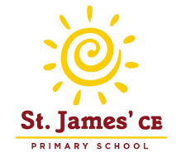
I’m in Year One, what might I like to read?
The Very Hungry Caterpillar – Eric Carle
The Bad-Tempered Ladybird – Eric Carle
Lullabyhullaba – Mick Inkpen
Peace at Last – Jill Murphy
Funny Bones – Allan Ahlberg
Cops and Robbers – Allan Ahlberg
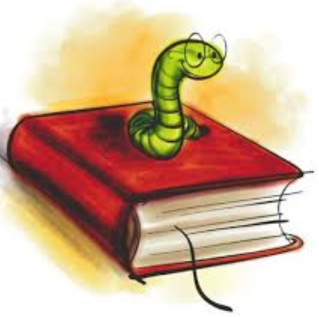
The Smartest Giant in Town – Julia Donaldson
The Paper Dolls – Julia Donaldson
A Bear Called Paddington – Michael Bond
A Lion in the Meadow – Margaret Mahy
Hairy Maclary from Donaldson’s Diary by Lynley Dodd
A Kitten Called Moonlight – Martin Waddell
The Emperor of Absurdia – Chris Riddell
There are Cats in this Book – Viviane Schwarz
Mister Magnolia – Quentin Blake
Mrs Armitage on Wheels – Quentin Blake
Katie Morag’s Island Stories by Mairi Hedderwick
My Friend Bear – Jez Alborough
Avacado Baby – John Burningham
The Tiger who came to Tea – Judith Kerr
Meg and Mog – Helen Nichol
Not Now Bernard – David McKee
A Dark, Dark Tale – Ruth Brown
Dogger – Shirley Hughes
The Trouble with Jack – Shirley Hughes
I Want My Hat Back – Jon Klassen
You Can’t Take an Elephant on the Bus – Patricia Cleveland Peck
Penguin – Polly Dunbar
You Choose! – Pippa Goodhart
Stanley’s Stick – Neale Layton
Develop your reading skills further and stretch yourself by trying these books….
The Diary of a Killer Cat – Anne Fine
Mrs Wobble the Waitress – Allan Ahlberg
Mr Majeika – Humphrey Carpenter
Flat Stanley – Jeff Brown
Emily’s Legs – Dick King-Smith
The Guard Dog – Dick King-Smith
The Magic Finger – Roald Dahl
The Giraffe and the Pelly and Me – Roald Dahl
The Heart and the Bottle – Oliver Jeffers
What to Do If an Elephant Stands on Your Foot – Michelle Robinson
How to Wash a Woolly Mammoth – Michelle Robinson
Dinosaurs in the Supermarket! – Timothy Knapman
The Hodgeheg – Dick King-Smith
Don’t Forget the Bacon – Pat Hutchins
The Princess and the Pea – Minnie Grey
The Whisperer – Nick Butterworth
The Silver Swan – Michael Morpurgo
The True Story of Three Little Pigs – Jon Scieszka
The Grandad Tree – Trish Cooke
Where’s My Teddy? – Jez Alborough
My Friend Bear – Jes Alborough
What If? – A H Benjamin
Man on the Moon – Simon Bartram
The Owl Who Was afraid of the Dark – Jill Tomlinson
Out for the Count – Anne Fine
Zahra’s Blessing – Shirin Shamsi
Too Small Tola – Atinuke
The World Made a Rainbow – Michelle Robinson

