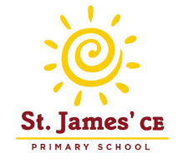
I’m in Year Two, what might I like to read?
The Story of Babar, the Little Elephant – Jean De Brunhoff
Zahra’s Blessing – Shirin Shamsi
The Cat Who Lost its Purr – Michelle Coxon
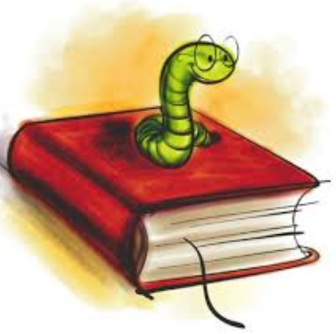
Choosing Crumble – Michael Rosen
Jinnie Ghost – Berlie Doherty
Gobbolino the Witch’s Cat – Ursula Williams
The Dunderheads – Paul Fleischman
The Tear Thief – Carol Ann Duffy
How to Live Forever – Colin Thompson
The Jolly -Rogers and the Ghostly Galleon – Jonny Duddle
The Day the Crayons Quit – Drew Daywatt
Clarice Bean, That’s Me – Lauren Child
The Diary of a Killer Cat – Anne Fine
Fungus the Bogeyman – Raymond Briggs
Mrs Wobble the Waitress – Allan Ahlberg
Pirate School: Just a Bit of Wind – Jeremy Strong
Uncle Gobb and the Dread Shed – Michael Rosen
Fluff the Farting Fish – Michael Rosen
Clever Polly and the Stupid Wolf – Catherine Storr
The Great Fire of London -- Gun Powder Plot -- Battle of Hastings -- Coronation of Elizabeth II
Mr Majeika – Humphrey Carpenter
Develop your reading skills further and stretch yourself by trying these books….
Dilly the Dinosaur Series – Tony Bradman
Mr Gum series - Andy Stanton
My Naughty Little Sister – Dorothy Edwards
The Amazing Adventures of Hercules, Jason and the Gold Fleece – C Zef
James and the Giant Peach – Roald Dahl
The Twits – Roald Dahl
The Famous Five Series – Enid Blyton
It Was a Dark and Stormy Night – Janet Ahlberg
Black Queen – Michael Morpurgo
Beaver Towers – Nigel Hinton
I Was a Rat! Or, the Scarlet Slippers – Philip Pullman
Nim’s Island – Wendy Orr
The Dragonsitter series – Josh Lacey
The Adventures of Captain Underpants – Dav Pilkey
The Man Whose Mother was a Pirate – Margaret Mahy
Mr Wolf’s Pancakes – Jan Fearnley
Press Here – Herve Tullet
The River that flows beside Me – Charlotte Guillain & Jo Empson
The Penderwicks – Jeanne Birdsall
Frightened Fred – Peta Coplans
Flat Stanley – Jeff Brown
The Heart and the Bottle – Oliver Jeffers
Emily’s Legs – Dick King-Smith
The Guard Dog – Dick King-Smith
The Magic Finger – Roald Dahl
The Giraffe and the Pelly and Me – Roald Dahl
The Enchanted Wood – Enid Blyton
The Snow Lady – Shirley Hughes
Counting on Katherine – Helaine Becker & Dow Phumiruk
Daisy and the Trouble with London – Kes Gray
A Ticket to Kalamazoo! – James Carter & Neal Layton
Milo’s Monster – Tom Percival
The Midnight Panther – Poonam Mistry
The Proudest Blue – Ibithaj Muhammed, S.K Ali & Hatem Aly
You Must Bring a Hat – Simon Philip & Kate Hindley
Too Small Tola – Atinuke
The World Made a Rainbow – Michelle Robinson

