Addition: Methods of Calculation |  | Subtraction: Methods of Calculation
Concrete materials (Numicon shapes, cubes, rekenrek etc)  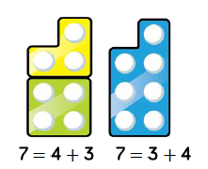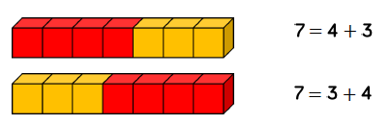 | Tens frame:  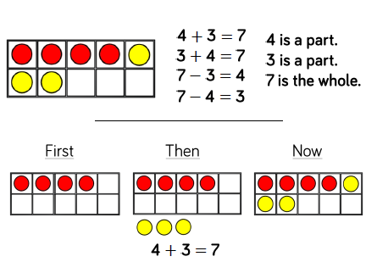 | Crossing out method:  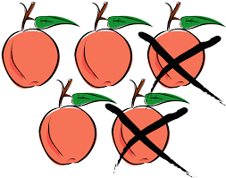5 – 2 = 3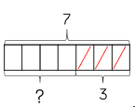 7 - 3 = 4 | 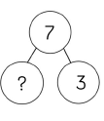  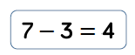  Part whole model:
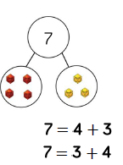  Part whole method:  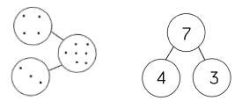 | Number tracks and number lines:  Counting forwards  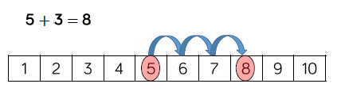  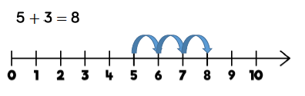 | Number tracks and number lines:  Counting backwards  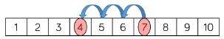
Multiplication: Methods of Calculation (x1 x2 x5 x10) |  | Division: Methods of Calculation
Repeated addition: Children use concrete and pictorial representations to solve problems.  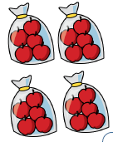  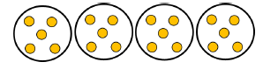  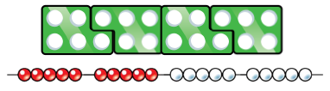 | Multiplication arrays:  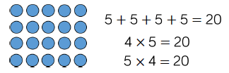  Children can be challenged to record multiplication formally | Sharing amounts: Children use concrete and pictorial representations to solve problems.  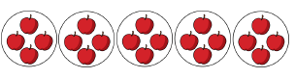 | In year 1 children use concrete and pictorial representations to solve problems. They are not expected to record division formally. Some children may be challenged with year 2 methods if mastery of sharing and grouping is evident.

St James’ Calculation policies Year 1-6

Year 1

Year 2
Addition: methods of calculation |  | Subtraction: methods of calculation
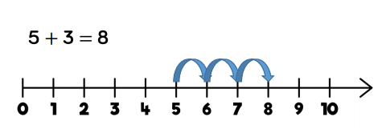  Used when jumping in ones and in tens. A good way of solving year 2 missing number questions. | Ten frames  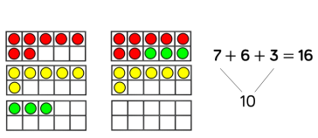  Using a ten frame using counters. Chn can also link this with the ten frame register displayed in the classroom. | Number lines  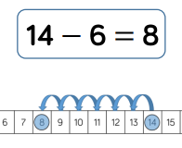  Used when counting back in ones and also jumps of 10 | 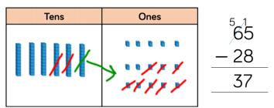  Formal method/ column method  Chn use the dienes to exchange one ten for ten ones.
Expanded method:  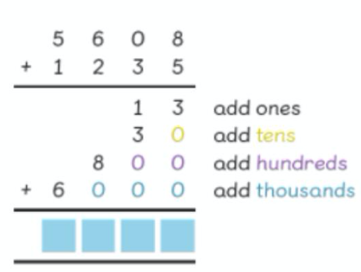 | Formal method/column method  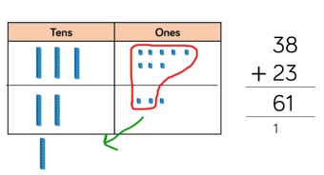  Chn are introduced to column method using dienes as support. Chn expected to regroup. | Using ten frame and visual representations  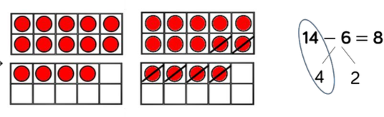  CPA approach used throughout all methods
Multiplication: methods of calculation |  | Division: methods of calculation
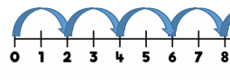  Number line/ hundred square  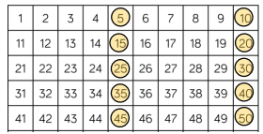  Understanding you are adding the same number each time ( 2, 5 and 10) | 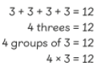  Repeated addition/equal groups  Introduced to equal groups and repeated addition. Chn draw equal groups to help solve the sums. | Bar model  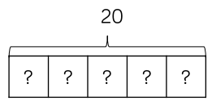  Chn use the part model to share the whole number between the parts (counters and drawing) | 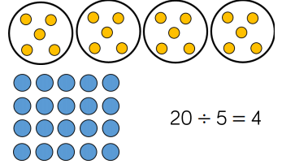  Concrete materials  Use of counters to share the number between equal groups.
Arrays  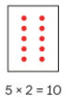  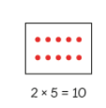  Chn are introduced to arrays to solve multiplication sums. Use counters for support. |  | 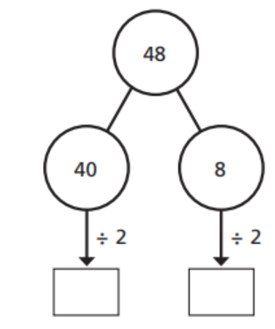  Part whole methods  This provides a clear  written method that  matches concrete  representation | Inverse link  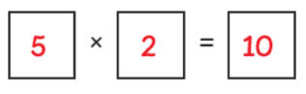  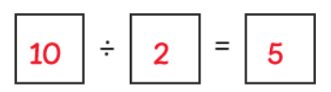  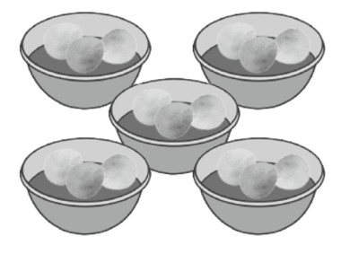

Year 3
Addition: methods of calculation |  | Subtraction: methods of calculation
Column addition with/without renaming  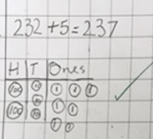 | Expanded column method | Column subtraction: without renaming  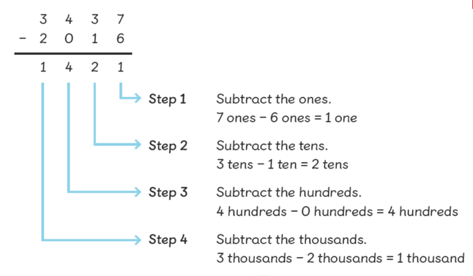 | Column subtraction with renaming  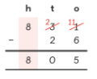  Discuss placement of digit when renaming
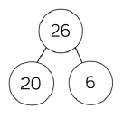  Partitioning (including flexible partitioning)  20 + 6 = 26  6 + 20 = 26  Addition is commutative | Using place value discs/Dienes to show renaming and using place value chart  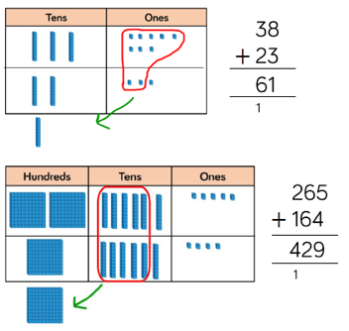  Number lines also used if necessary.  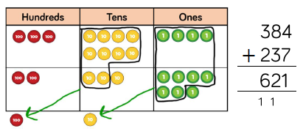 | Subtraction using partitioning  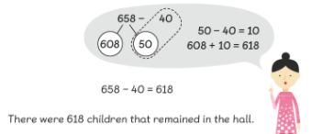 | Subtraction using a number line:  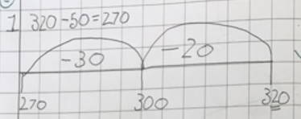
Multiplication: methods of calculation |  | Division: methods of calculation
Bar model:  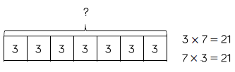  Multiplication is commutative | Expanded column method  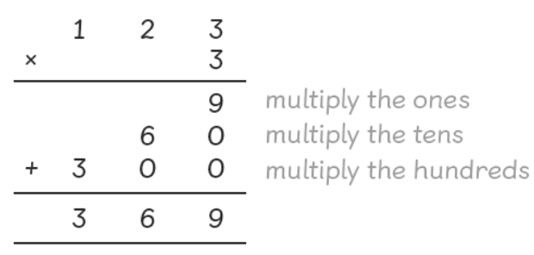 | Bar model:  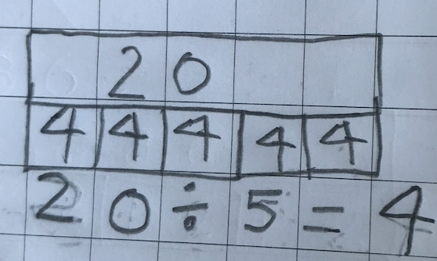 | Partitioning:  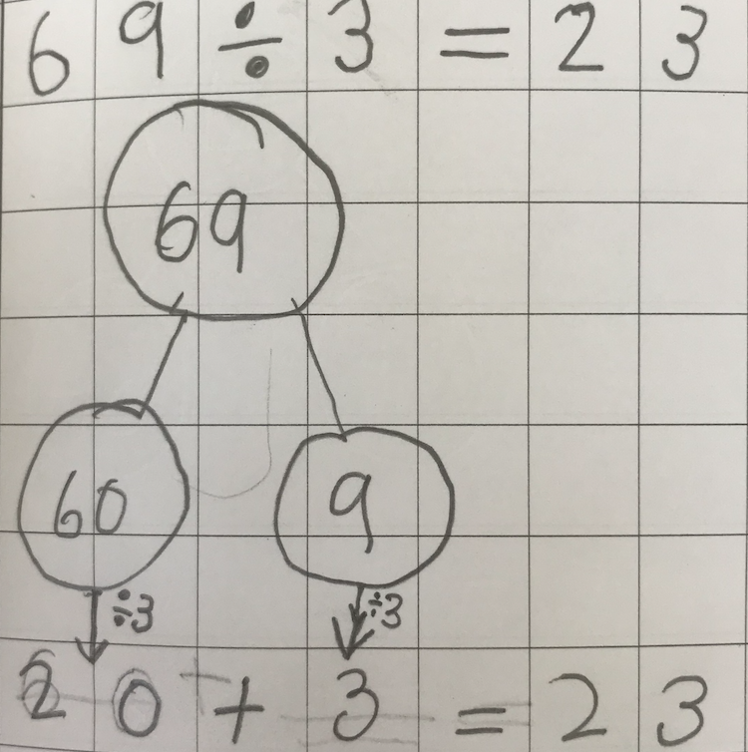
Arrays:  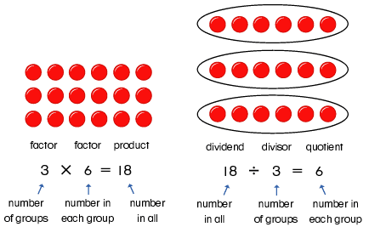 | Partitioning:  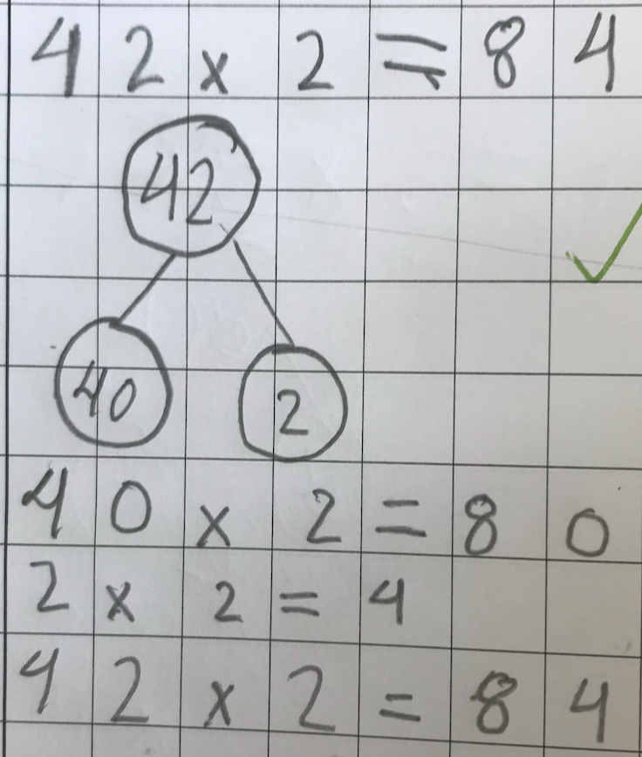 | Arrays: | 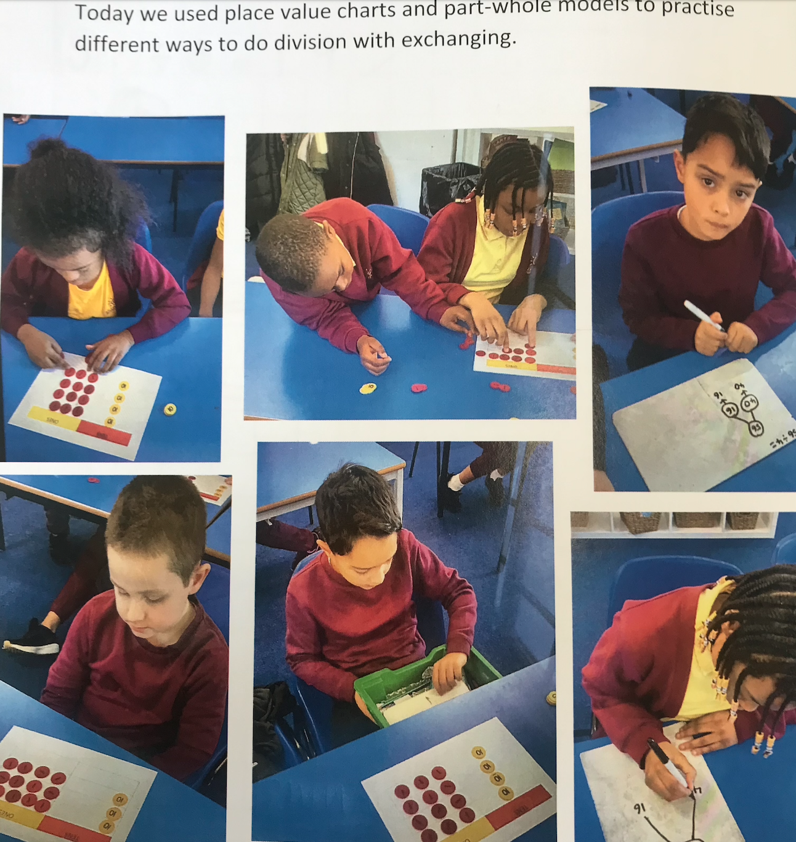
Addition: methods of calculation |  | Subtraction: methods of calculation
Expanded addition method | Column method: Can be used with and without renaming  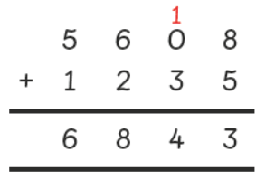 | 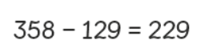  Subtraction using partitioning  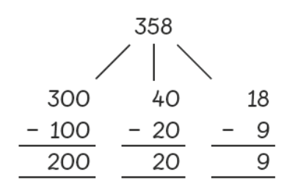 | Column subtraction with renaming  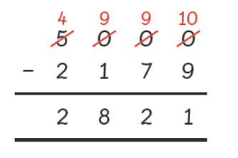  Discuss placement of digit when renaming
Part whole & number line  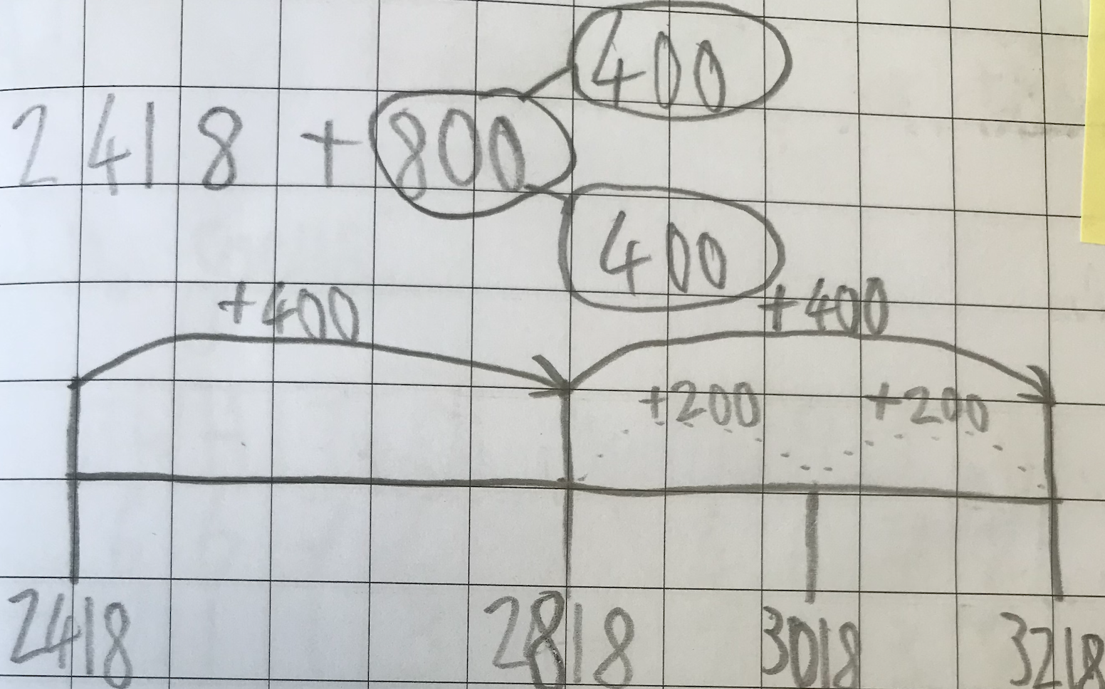 | Using representations to support/deepen addition knowledge  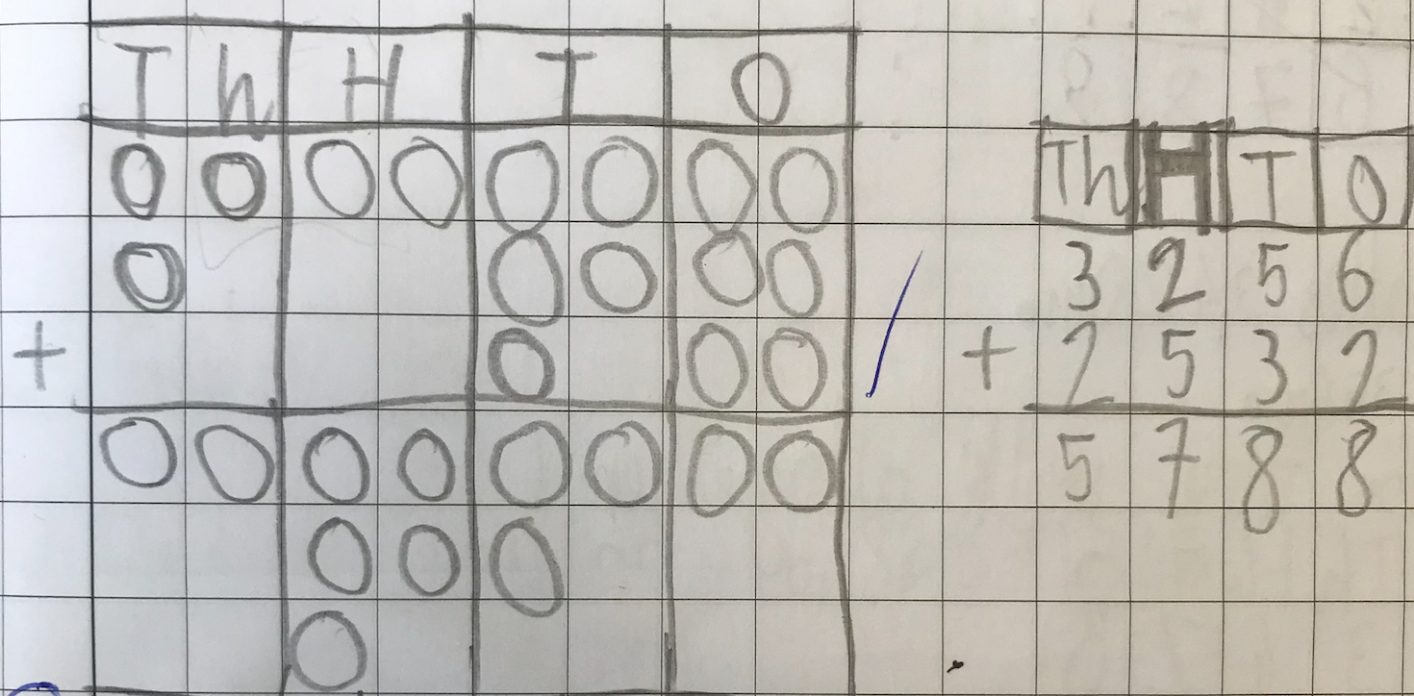 | Using representations to support/deepen understanding  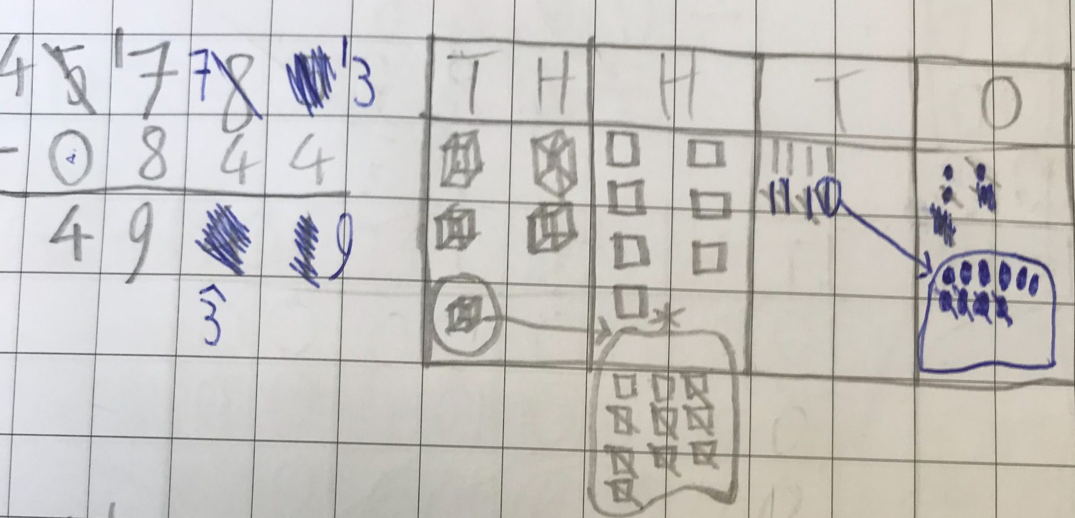
Multiplication: methods of calculation |  | Division: methods of calculation
Part whole method:  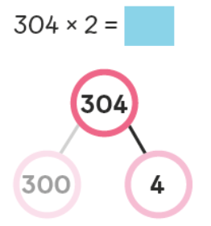  Step 1: partition into place values  Step 2: 300x2=600  Step 3: 4x2=8  Step 4: add together totals of step 2 and 3  Can be done for three digit numbers etc | 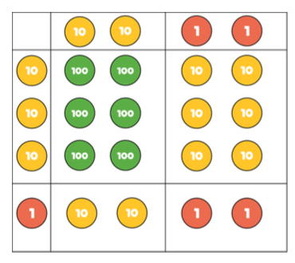  Grid method: This method may be best for GDS learners and can be adapted so numbers replace concrete materials` | 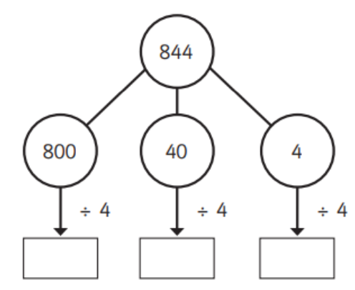  Partitioning | Short division method  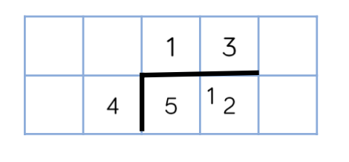
Expanded column method  Place emphasis on place value | Column method with and without renaming  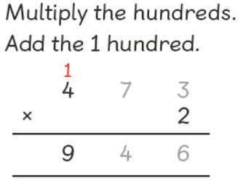 | Flexible partitioning  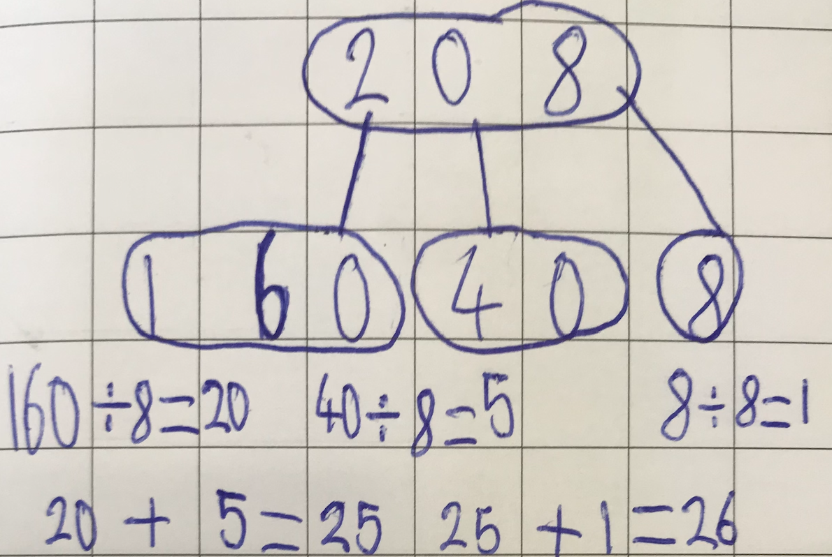 | Arrays 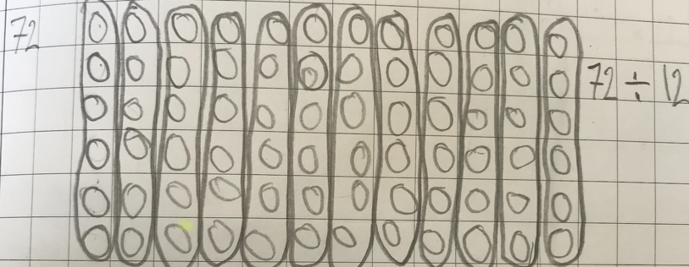
Year 4
Addition: methods of calculation |  | Subtraction: methods of calculation
Expanded Notation  432 + 567=  (400+30+2) + (500+60+7)=  400 + 500 = 900  30 + 60 = 90  2 + 7 = 9  Add together - 999 | Column method: Can be used with and without renaming | 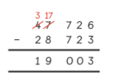  Column subtraction with and without renaming | Place value grid to support where necessary  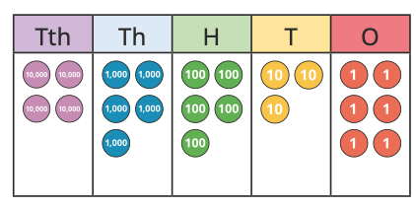
Expanded addition method | 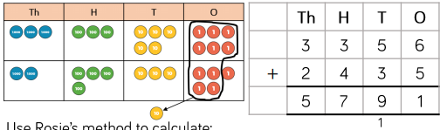  Using place value discs to show the value of a digit in a number and how/why they might have to exchange. | Use of bar models to support with solving word problems  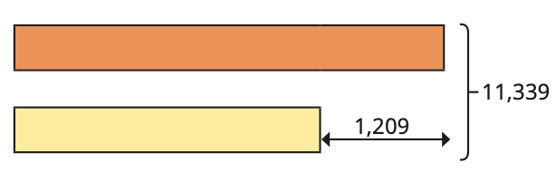 | Greater emphasis on reasoning and problem solving  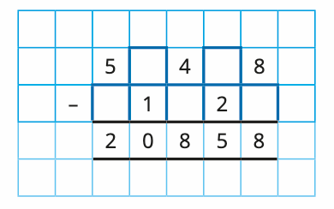
Multiplication: methods of calculation |  | Division: methods of calculation
Expanded column method.  This method can also be used for 3x2 digits and 2x2  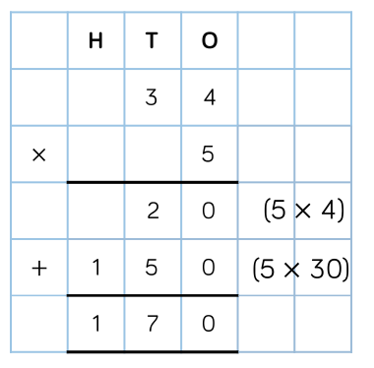 | Grid method:  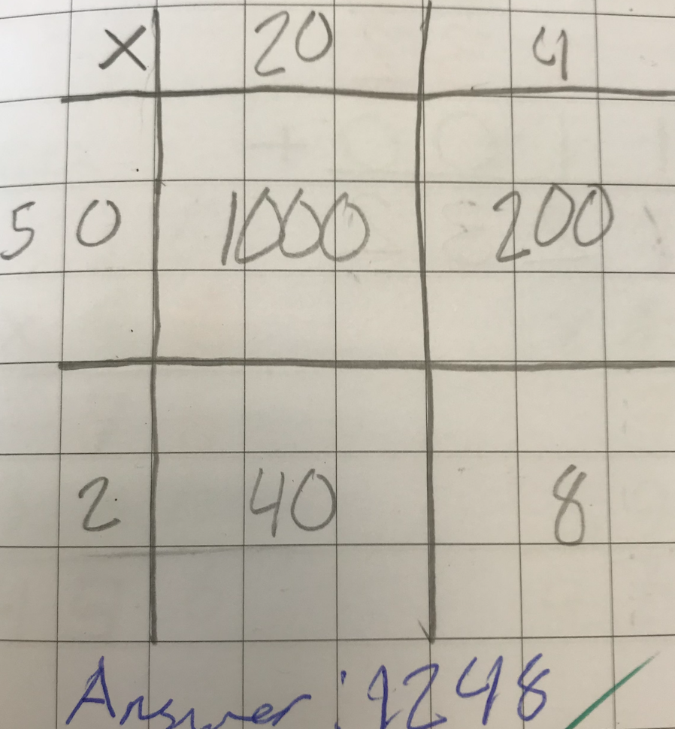 | 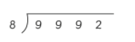  Sort division with (and without) remainder  Children demonstrate place value knowledge and understanding that ‘eight fits into nine thousand 1 thousand times and the remaining thousand exchanges to ten hundreds and so on.  Some children may be able to show their remainder as a fraction (divisor as the denominator) and/or decimal | Place value grid to support where necessary  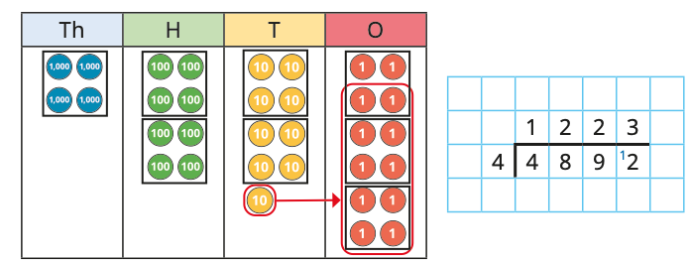
Standard column method:  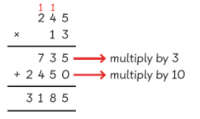 |  | Greater emphasis on reasoning and problem solving  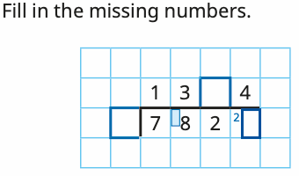
Year 5

Year 6
Addition: methods of calculation |  | Subtraction: methods of calculation
Column method: Can be used with and without renaming | Greater emphasis on reasoning and problem solving  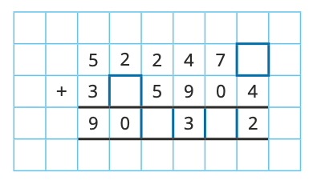 | Column subtraction: without renaming | Greater emphasis on reasoning & problem solving
Reasoning skills  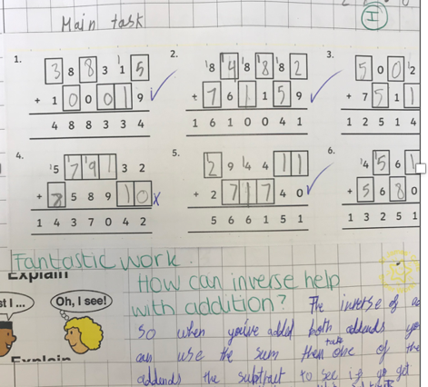 | Children may use a range of methods, whichever is their preferred | Reasoning skills  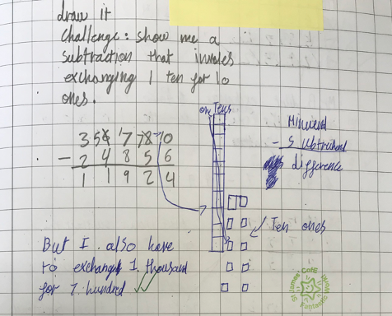 | Children may use a range of methods, whichever is their preferred
Multiplication: methods of calculation |  | Division: methods of calculation
Partitioning  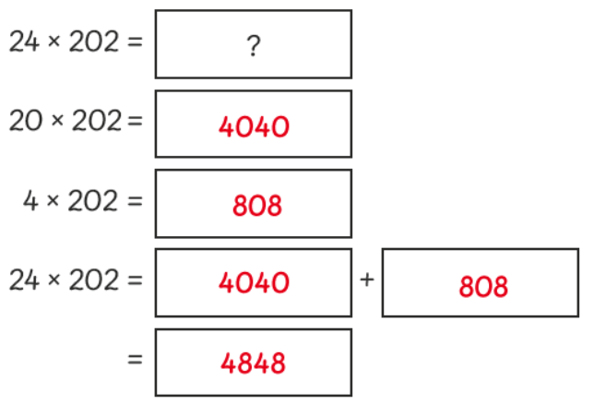 | Grid method: can be adapted so numbers replace concrete materials  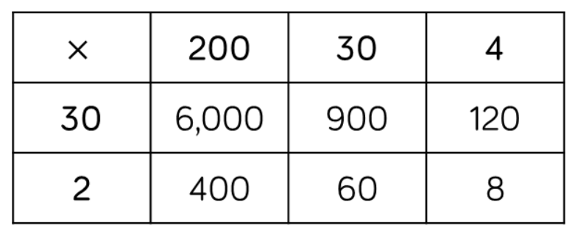 | Long Division: With and without a remainder  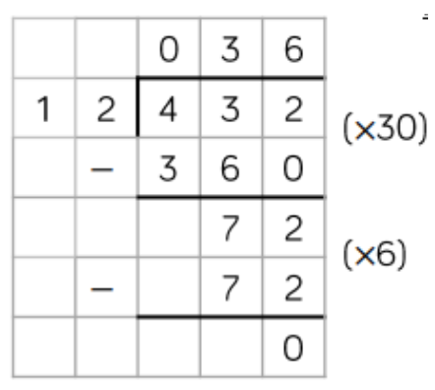 | Short Division with remaining and no remaining.  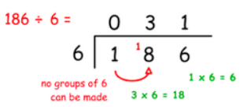
Expanded column method  Place emphasis on place value | Formal written method  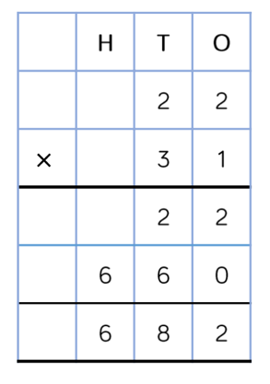 | Chunking through long division method:  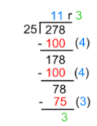 | Partitioning:  864 divide by 4  800 + 60 + 4 =  800 divided by 4 = 200  60 divided by 4 = 15  4 divided by 4 = 1

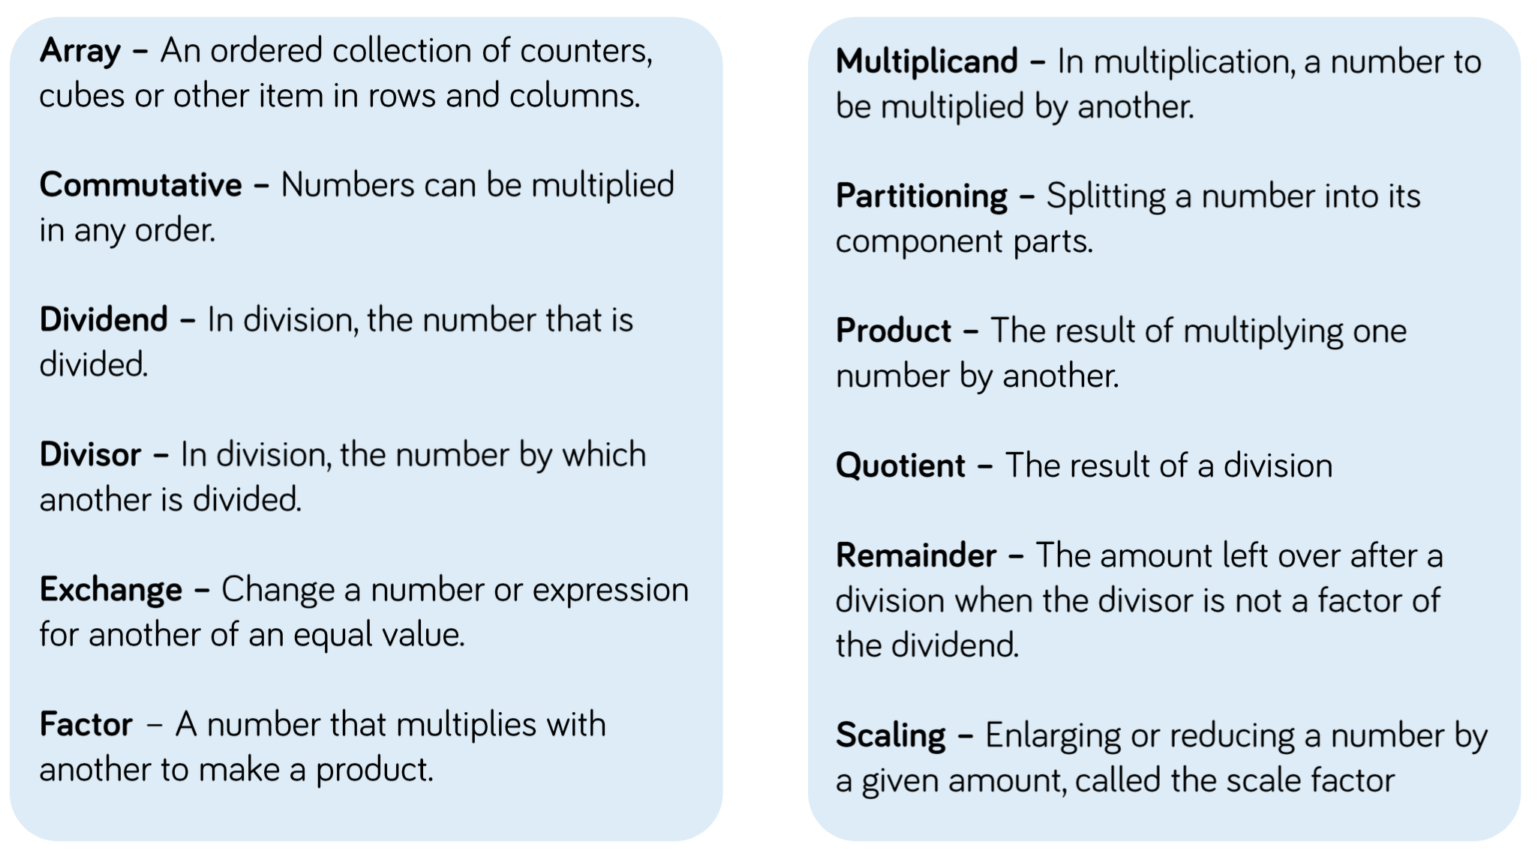
Glossary of terms

