I have signed my name to show that I have read & understood this agreement. If I have any questions, I will speak to a trusted adult. Note: A trusted adult is someone I can talk to who I know will help me. |  | Signature: | My trusted adults in school are | My trusted adults at home are
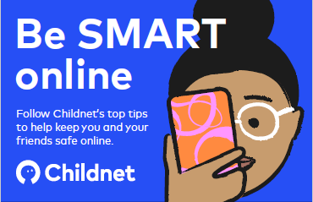  - I communicate & collaborate online with people I already know & have met in real life or that a trusted adult knows about.  - I ask permission – at home or school, I only use devices, apps, sites & games I am allowed to and when I am allowed to. |  | These statements can keep me & others safe & happy at school and home! | 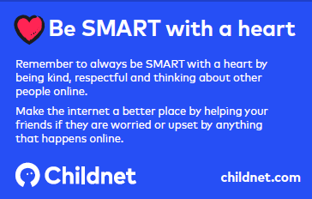  - I’m a good friend online – I won’t share or say anything I know would upset another person.  - I’m not a bully – I know just calling something fun or banter doesn’t stop it hurting someone else. I don’t post, make or share unkind, hurtful or rude messages or comments.
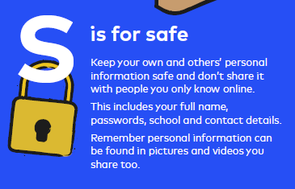 | 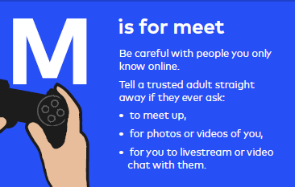 | 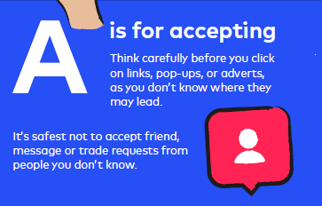 | 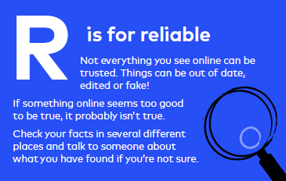 | 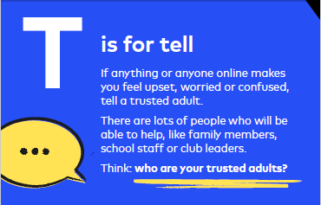
- I am a secure online learner – I keep my passwords to myself;  friend’s don’t share passwords!  - I don’t take photos or videos of people without them knowing or agreeing to it – and I never film people getting angry or upset. Ask a trusted adult to help if you are worried about a situation.  - I keep my body to myself online; I don’t send photos or videos, it’s my body and no-one should tell me what to do with it. | - I never pretend to be someone else online – it can be upsetting or even dangerous.  - I would check with a trusted adult before I ever agreed to meet an online friend and never go to meet someone alone.  - I don’t go live (videos anyone can see) on my own – always check with a trusted adult before video chatting with anybody for the first time. | - I am careful what I click on – I don’t click on unexpected links or popups. I wouldn’t download software without checking with a trusted adult first.  - I know online friends might not be who they say they are – I’m careful when someone wants to be my friend, if I haven’t met them face to face, I can’t be sure who they are. | - I behave the same way on devices as face to face and so do my teachers.  - I say no online if I need to; I don’t have to do something just because someone dares or challenges me to do it, or to keep a secret. I anyone worries, upsets or confuses me online, I should say ‘No’ stop chatting & tell a trusted adult immediately. | - I ask for help if I’m scared or worried – talk to a trusted adult if anything upsets or worries me. If I get a funny feeling I talk about it.  - I know it’s not my fault if I see or someone sends me something bad – I won’t get in trouble, but I mustn’t share it. Instead, I’ll talk to my trusted adult.  - If I make a mistake, I don’t try to hide it but ask for help.

