My name is
My trusted adults in school are
My trusted adults at home are
A trusted adult is someone I can talk to who I know will help me.
These are my rules for staying safe on the internet
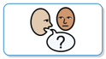
I DO:
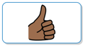
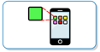
- Ask a trusted adult if I want to use a computer or iPad;
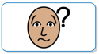
- Use only activities that a trusted adult has said I can use;
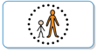
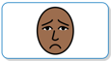
- Ask a trusted adult if I don’t know what to do, or something is wrong;
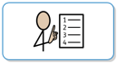
- Tell a trusted adult if I see something that upsets me on the screen;
I can speak up for a friend and tell someone if I think they are worried or need help;
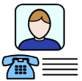
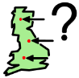
- Check with a trusted adult before sharing any personal information,
like my birthday or where I live;
- Check with a trusted adult before sharing other people’s stories or photos.
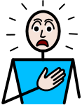
I DON’T:
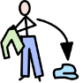
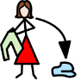
- Do dares or challenges, even if someone tells me I must;
- Change my clothes in front of a camera
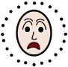
- Share my passwords with others, they are only for me to use;
- Speak unkindly to others on the internet.
I AM:
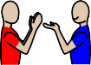

- Kind and polite to everyone; I know that the internet can be great fun, but only if
everyone follows these simple rules.
This is a picture of me using the internet |  | Activities I like to do on the internet at  school or at home

