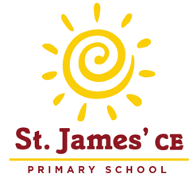
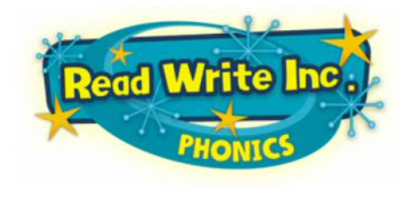
Parents’ Guide to Read Write Inc.

Phonics
We use 44 sounds to make all the words in the English language. We’ve got 44 sounds and only 26 letters.
We have to group letters together to read and write some sounds e.g. ‘igh’, ‘air’. These are known as ‘special friends.’

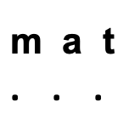
All words are made up of individual sounds and these sounds are merged together to form words.
E.g. in ‘mat’ we have the sounds and in ‘ship’ we have the sounds

Sounds
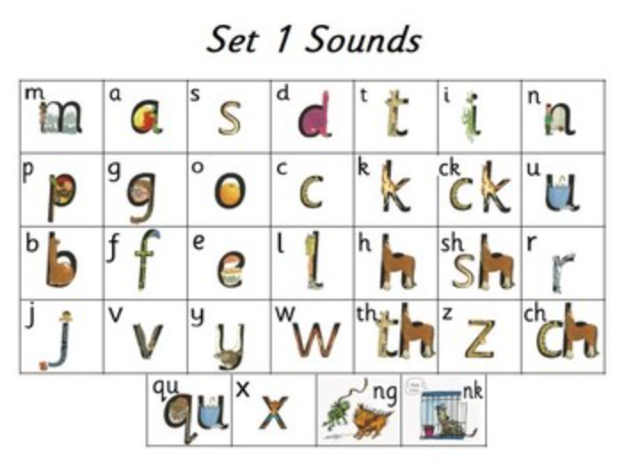
These are the sounds we teach the children, and the order in which we teach them:

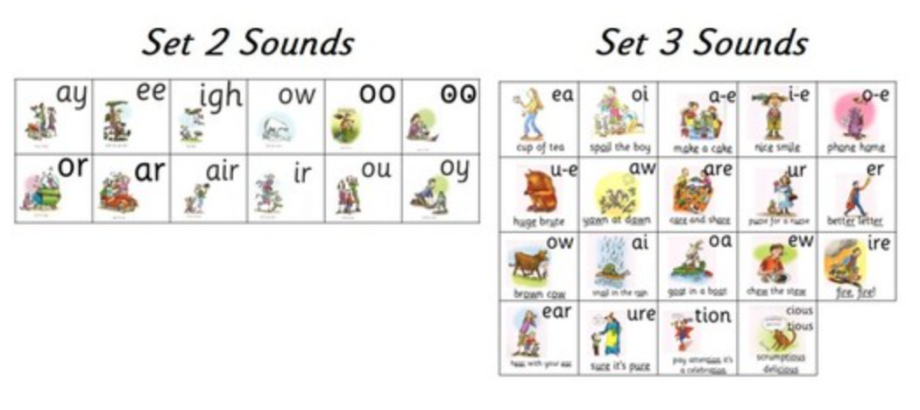

Sound Blending

Once the children know their sounds, they can begin to sound out words (segment) and blend the sounds in order to begin to read.

The teachers will introduce your child to a toy frog called Fred once he or she is ready to start reading words. Fred can only say the sounds in a word and needs your child to help him read the word. Fred will say the sounds and children will work out the word. For example, Fred will say the sounds c–a–t, and children will say the word cat. This is Fred Talk: sounding out the word.
Fred can only sound out the words in the English language that are spelt phonetically- these are called green words. Words not spelt in this way are called Red words. These include words such as ‘the’. These cannot be sounded out but must just be recognised by sight.
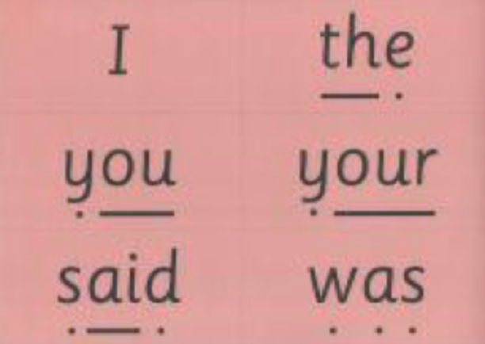
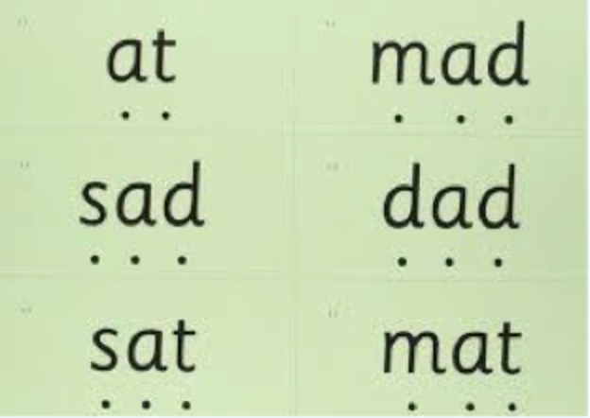

Reading
Children will be sent home with a reading book with words which they should be able to sound out and read. Re-reading the same book helps children to become confident readers. Each time they re- read, they build their fluency/speed and comprehension. This helps promote a love of reading and encourages children to want to read because they can read all of the words in the storybook.
We send this book home because they can ‘accurately’ read EVERY word. We want them to practise and build their reading skills with both fluency and comprehension. We want them to read these books like storytellers.
It is always beneficial for children to read as much as they can at home, so as well as this reading folder book, please read a variety of picture books for pleasure with your child. They do not have to be able to read the words in this book, but can explore the pictures and story with you.

